URL - it is the reference to a web resource that specifies the resource locator in the network and the mechanizm for retrieving the resource.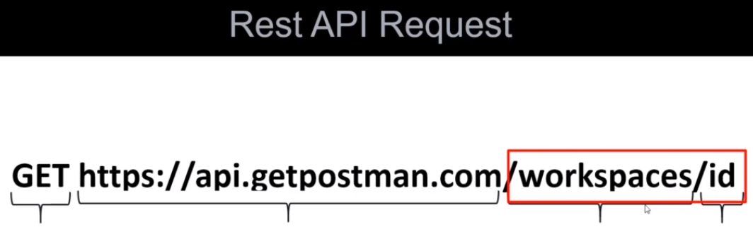

In this example we retrieving the resource called workspace/id.

Get ← it is a HTTP method that is indicate haw we want to interact with API

<https://api.getpostman.com> ← this part call **base url**

/workspaces ← this part call endPoint and this is: /workspaces/id also endPoint, we just requesting the specific workspace. For the server it can have different endPoints. For example /kollektions or /environment.

If we enter all the urls except the id then we will get the list of all workspaces. If we include id we will get the specific workspace. So the id can also be called a path parameter.